**Experiment 2.2**

**Naive Bayes**

**Student Name: Ishu Rattan UID:20BCS7755**

**Branch: CSE Section/Group:20BCS_MM_806-B**

**Semester: 5th**

**Subject Name: Machine Learning Lab Subject Code: CSP-317**

1. **Aim/Overview of the practical:**

Apply naive bayes on any dataset**.**

1. **Source Code:**

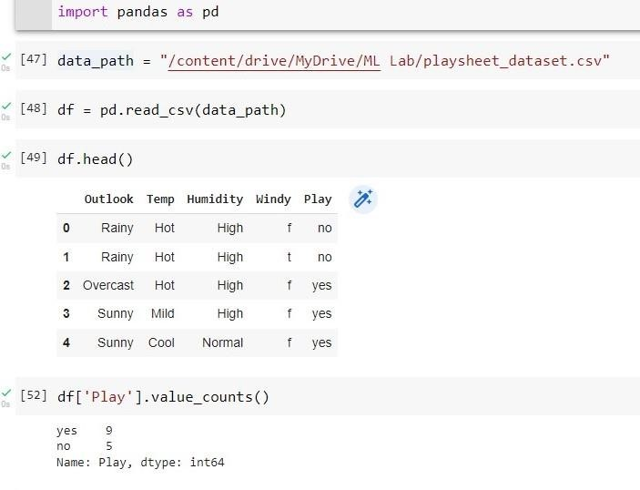

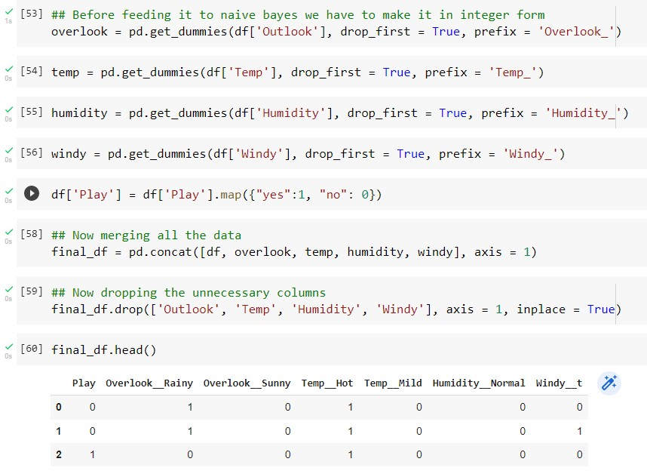

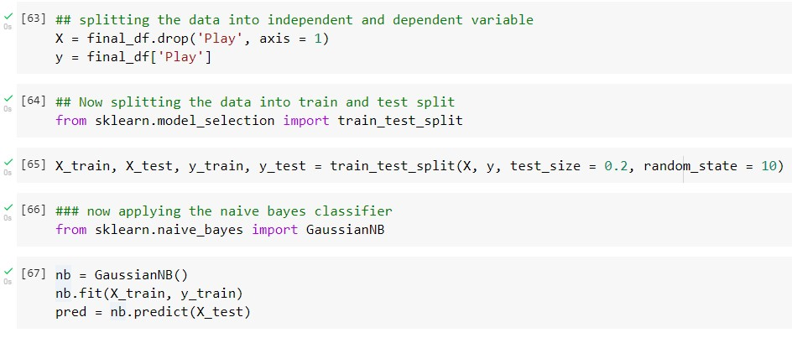

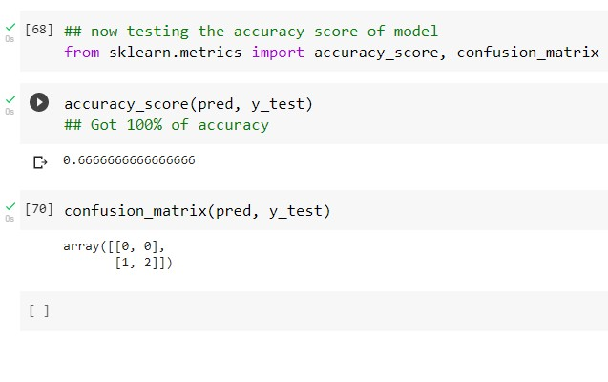

**Learning outcomes (What I have learnt):**

* 1. Learn about the Naive Bayes algorithm
  2. Learn to perform the Naive Bayes algorithm on weather dataset
  3. Learnt about the exploratory data analysis
  4. Learn to optimize the Model
  5. Got the clear concept of Naive Bayes classifier **Evaluation Grid :**

|  |  |  |  |
| --- | --- | --- | --- |
| **Sr. No.** | **Parameters** | **Marks Obtained** | **Maximum Marks** |
| **1.** | **Student Performance (Conduct of experiment) objectives/Outcomes.** |  | **12** |
| **2.** | **Viva Voce** |  | **10** |
| **3.** | **Submission of Work Sheet (Record)** |  | **8** |
|  | **Total** |  | **30** |